**Task 4: Communicating Insights and Analysis**

Hello, I’m Soha Khan, and I’m excited to present a set of insights that could help inform your business decisions. I appreciate the guiding questions you provided, as they gave me a clear understanding of the areas you're focused on. I trust that the analysis will be useful as you explore new opportunities and strategize for the future.

### **Data Preparation and Validation Summary**

Before analyzing the data, I performed a thorough data cleaning process to ensure accuracy and reliability:

* Ensured that all transactions had a quantity of at least 1 and a unit price greater than zero, eliminating issues caused by returns, test entries, or invalid records.
* Verified that there were no missing or corrupt values in key fields used for analysis.

These steps helped ensure that all insights are based on clean, trustworthy data, allowing for confident and strategic decision-making.

**Revenue by month for the year 2011.**

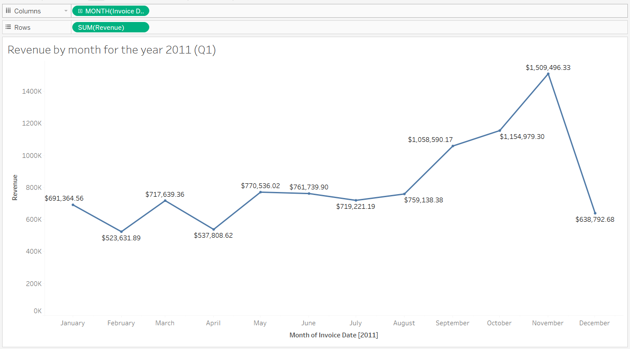

* From January to May, the revenue showed some fluctuations—there were ups and downs, indicating inconsistent performance during this period.
* Between May and August, the revenue trend was relatively stable, suggesting a period of steady performance without major changes.
* Starting from August, the revenue began to increase, showing signs of growth or improved sales.
* However, towards the end of the year, there was a notable decline, meaning revenue dropped significantly in the final months.

### **Top 10 countries by revenue and their quantity**

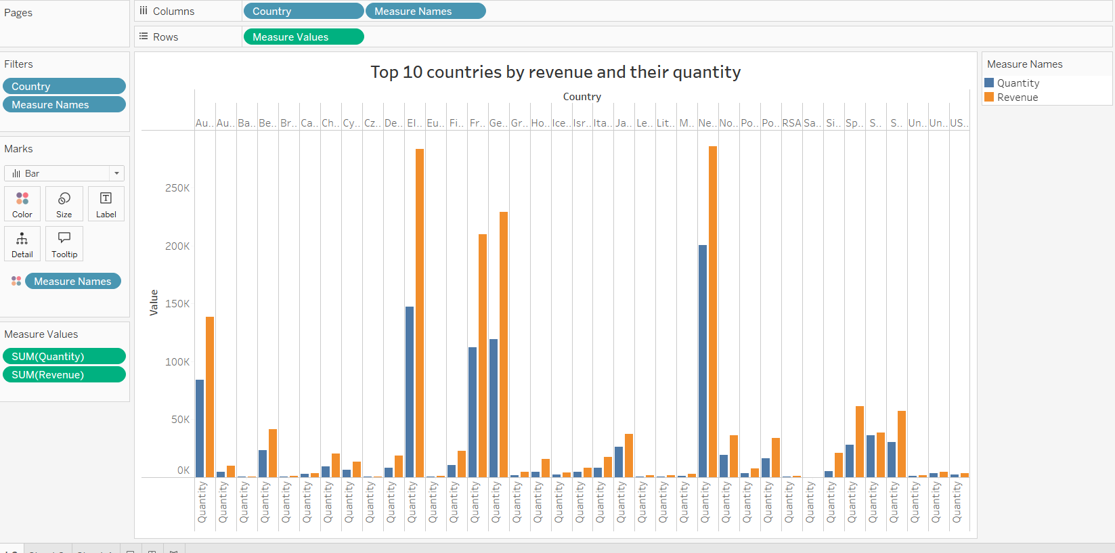

In reviewing the data on international performance, we identified the Top 10 countries based on total revenue and quantity sold.

* Notably, the United Kingdom was not among the top performers, which is unusual given its market size and may warrant further investigation.
* Countries such as the Netherlands, Germany, France, and Australia stood out with consistently higher revenue and strong sales volumes compared to other regions.
* These markets not only contributed a large share of total revenue but also demonstrated healthy customer demand, indicating solid market penetration and potential for further growth.

**Top 10 Customers by Revenue:**

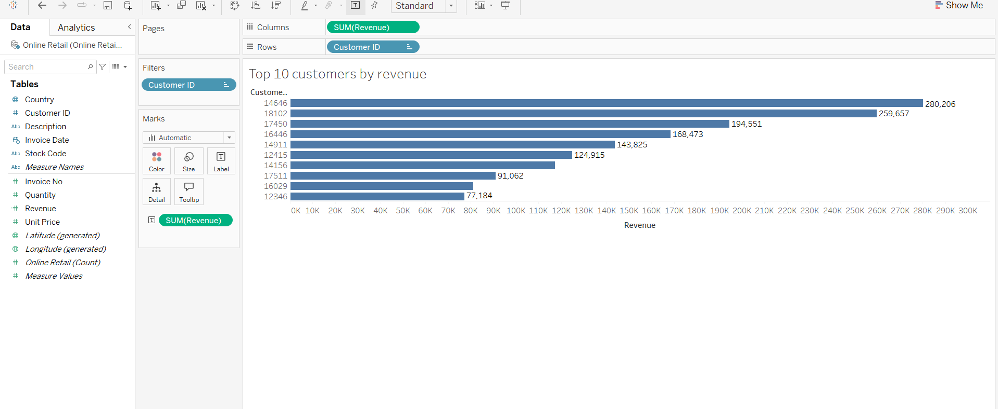

As requested, analyzed the top-performing customers based on total revenue generated. This gives us valuable insight into who our most valuable clients are and where relationship-building could drive even more business.

* The Top 10 customers together account for a significant portion of total revenue, confirming that a small group of high-value clients have a large impact on our overall sales performance.
* These customers show consistent purchase behavior and high order values, indicating strong loyalty or recurring needs for our products.
* Several of these top customers are located in high-performing countries like the Netherlands, Germany, and France, which aligns with our geographic revenue analysis.

Strategic Insight:

* Understanding what these customers are buying, when, and how often can help us tailor offers, introduce loyalty programs, or even offer exclusive deals to maintain and grow their spend.

### **Revenue by countries**

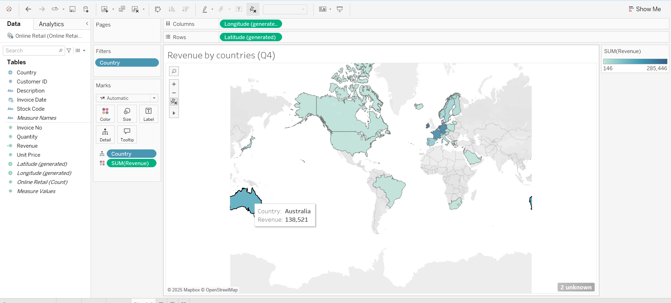

In response to the CEO's request, analyzed product demand by country, measured by quantity sold excluding the United Kingdom.

* The countries with the highest demand for our products are Netherland, Ireland, France, Germany, Australia
* These markets show consistently high purchase volumes, indicating strong product-market fit and robust customer engagement.

Strategic Implication:

* These high-demand countries represent key growth markets. Investing in targeted promotions, improved logistics, or region-specific product bundles could further boost sales.